SIMATS ENGINEERING
ASSESSMENT TOOL 3

COURSE NAME: Database Management Systems COURSE CODE: CSA0509

QUESTIONS
Q.N  o | Question | Bloom's Level
1 | Identify and correct errors in a given SQL CREATE TABLE statement with incorrect syntax and missing constraints. | BL2 –  Understand
2 | Debug an SQL query that incorrectly uses aggregate functions without GROUP BY and fix the issue. Bloom’s Level: | BL2 –  Understand
3 | Correct a faulty SELECT query where column names are misspelled or improperly referenced. | BL1 –  Remember
4 | Fix errors in an SQL query using JOIN, where the join condition is missing or incorrect. | BL3 – Apply
5 | Identify and correct a subquery error where multiple values are returned instead of a single value. | BL2 –  Understand
6 | Debug a VIEW creation statement that contains invalid column references or syntax errors. | BL1 –  Remember
7 | Examine an SQL query with unnecessary conditions and optimize it by simplifying the WHERE clause. | BL3 – Apply
8 | Identify violations of integrity constraints in a given table and correct them. | BL2 –  Understand

9 | Fix a relation that violates 1NF or 2NF by removing repeating groups or partial dependencies. | BL3 – Apply
10 | Identify redundant attributes in a relation and apply basic normalization (up to 3NF) to improve design. | BL3 – Apply

QUESTION:1 Identify and correct errors in a given SQL CREATE TABLE statement with incorrect syntax and missing constraints.

ANSWERS:
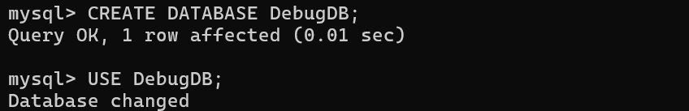

ERROR:
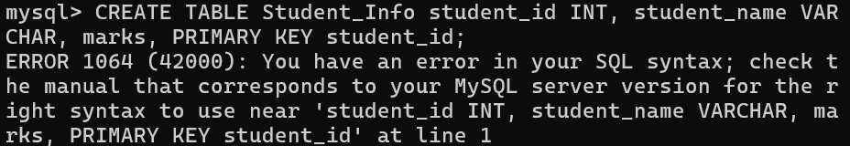

CORRECTED:

QUESTION: 2 Debug an SQL query that incorrectly uses aggregate functions without GROUP BY and fix the issue. Bloom’s Level:

ANSWERS:
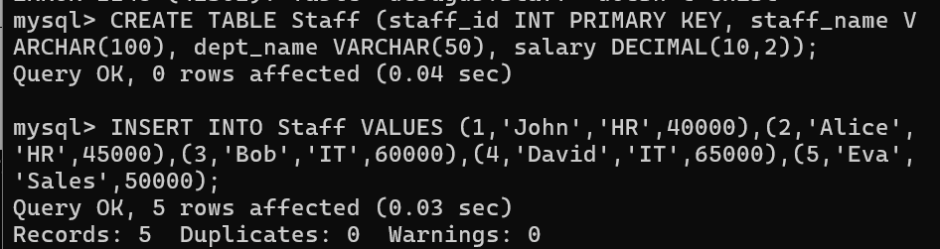

ERROR:
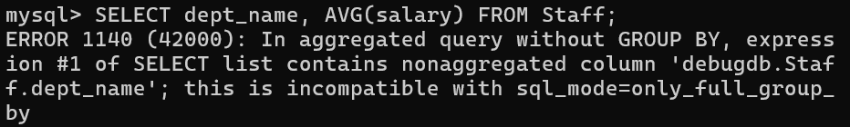

CORRECTED:
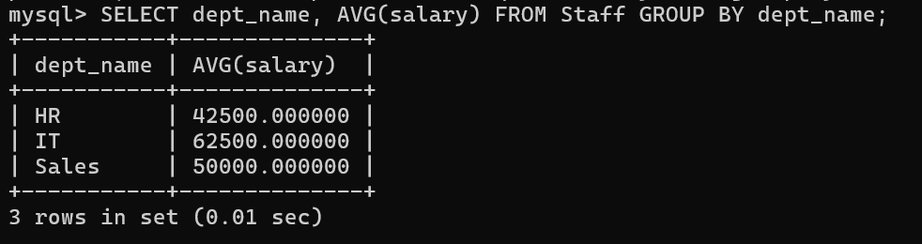

QUESTION: 3 Correct a faulty SELECT query where column names are misspelled or improperly referenced.

ANSWERS:
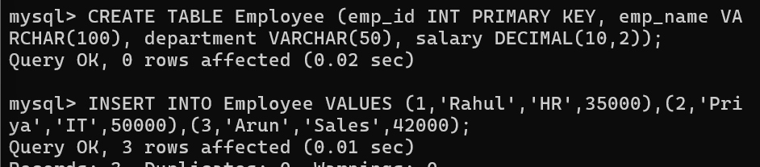

ERROR:

CORRECTED:
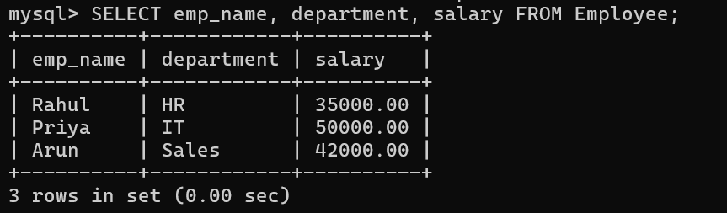

QUESTION: 4 Fix errors in an SQL query using JOIN, where the join condition is missing or incorrect.

ANSWERS:
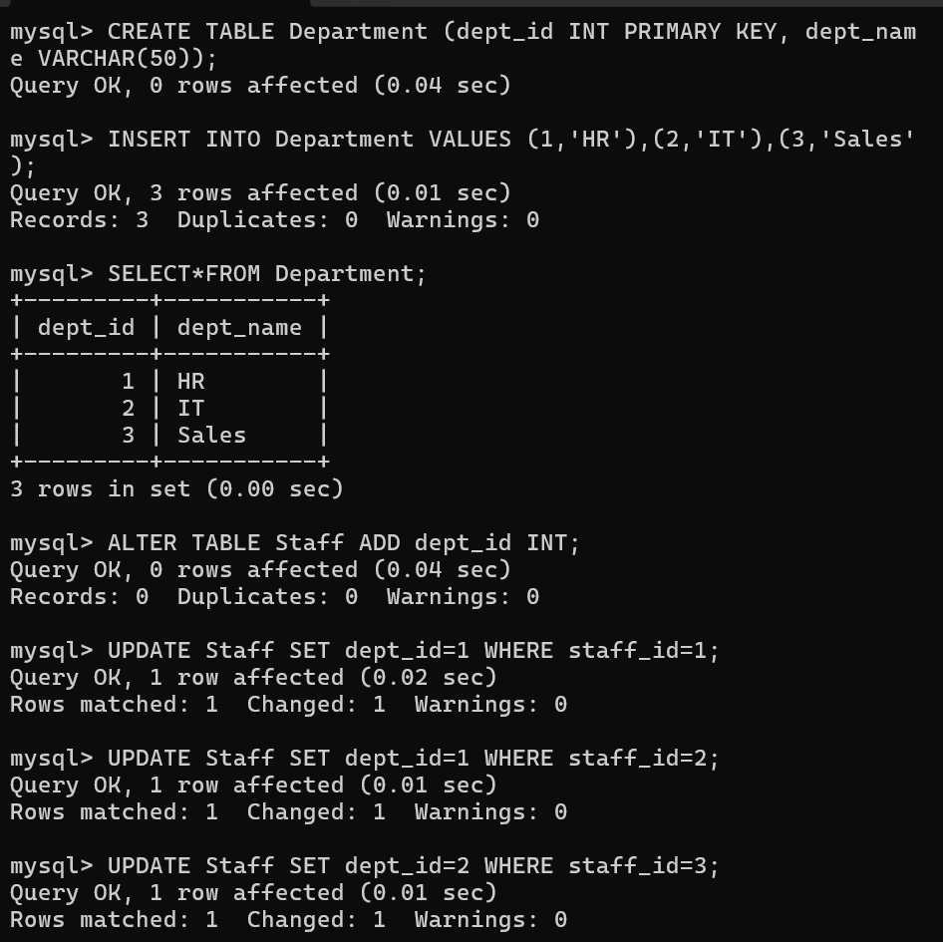

ERROR:
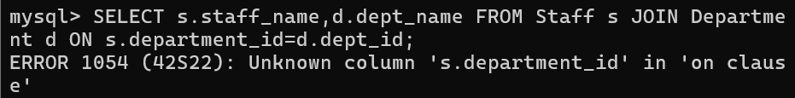

CORRECTED:
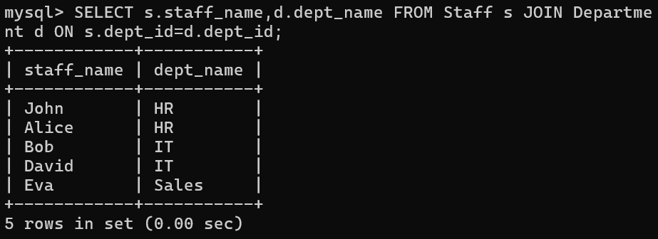

QUESTION: 5 Identify and correct a subquery error where multiple values are returned instead of a single value.

ANSWERS:
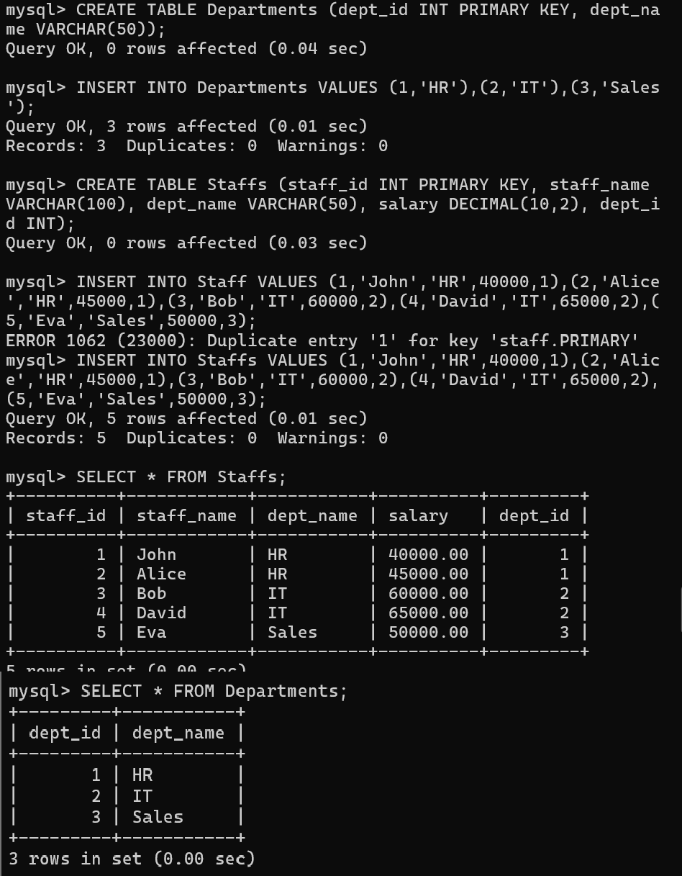

ERROR:

CORRECTED:
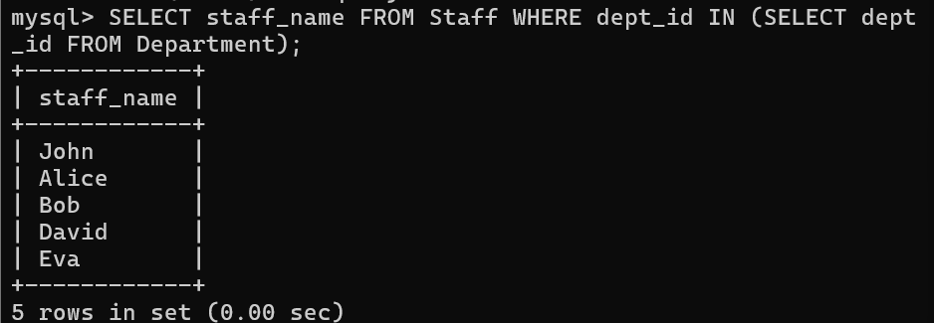

QUESTION: 6 Debug a VIEW creation statement that contains invalid column references or syntax errors.

ANSWERS: ERROR:

CORRECTED:
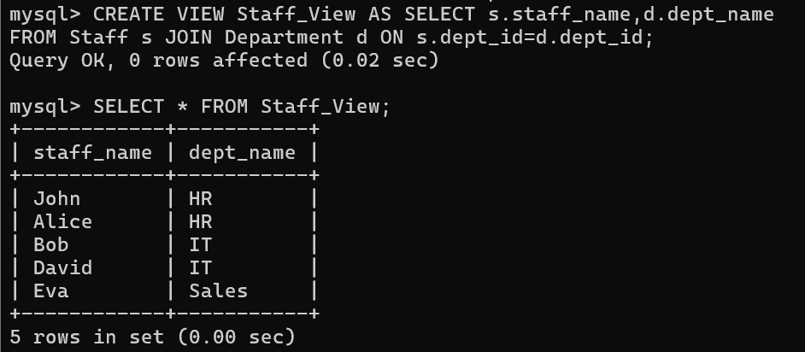

QUESTION: 7 Examine an SQL query with unnecessary conditions and optimize it by simplifying the WHERE clause.

ANSWERS:
ORIGINAL (UNOPTIMIZED):
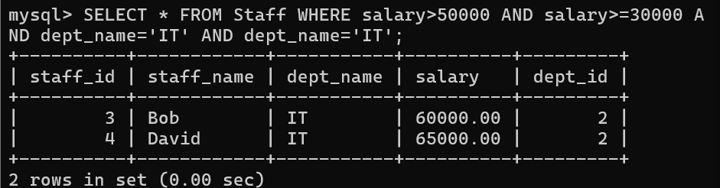

CORRECTED (OPTIMIZED):
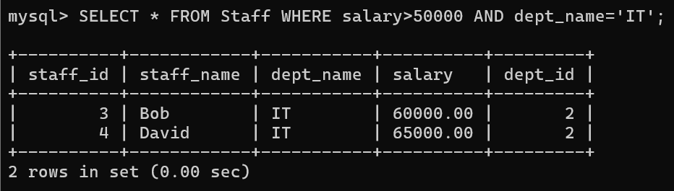

QUESTION: 8 Identify violations of integrity constraints in a given table and correct them.

ANSWERS:
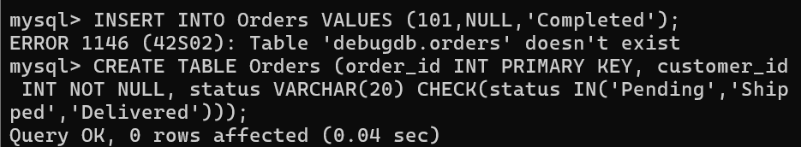

ERROR:

CORRECTED:
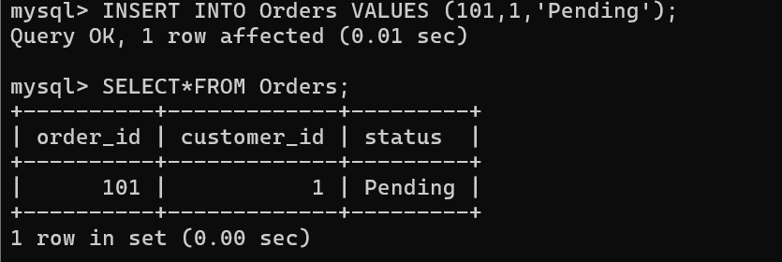

QUESTION: 9 Fix a relation that violates 1NF or 2NF by removing repeating groups or partial dependencies

ANSWERS:
ERROR:
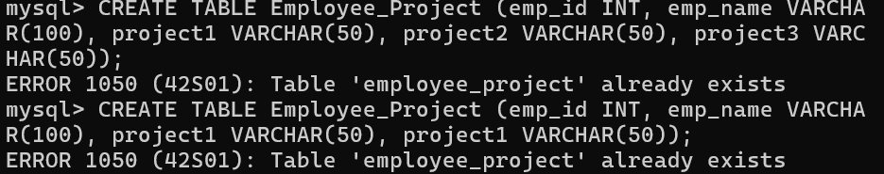

CORRECTED:
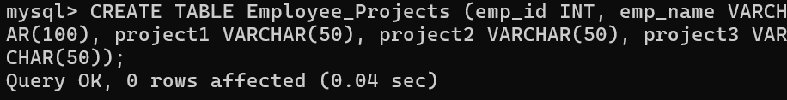
QUESTION: 10 Identify redundant attributes in a relation and apply basic normalization (up to 3NF) to improve design.

ANSWERS:
